Section 1: Case Summary

Scenario Title:
Keywords: | Beta blocker overdose, high-dose insulin, glucagon
Brief Description of Case: | A 44-year-old male presents to the emergency department following the ingestion of an entire bottle of metoprolol. Decontamination strategies should be utilized alongside consultation with poison control. Patient clinically deteriorates as the drug reaches peak effects, requiring IVF, atropine, glucagon, multi-dose vasopressors, high dose insulin, and a discussion around potential salvage therapies.

Goals and Objectives
Educational Goal: | To allow learners to identify and treat a severe beta blocker overdose requiring maximal medical therapy, including infrequently utilized therapies.
Objectives:  (Medical and CRM) | Medical  - Identify beta blocker toxicity  - Provide decontamination and initial supportive care  - Initiate appropriate management of severe beta blocker toxicity  CRM  - Mobilize resources to complete simultaneous investigation and treatment of an unstable patient including poison control and relevant consultants  - Anticipate and plan for a potentially critically unwell patient
EPAs Assessed: | ME 2.4 Initiate medical treatment of the patient with an overdose, toxic ingestion or  exposure, including specific antidote therapy.

Learners, Setting and Personnel
Target Learners: | ☐ Junior Learners |  | ☒ Senior Learners |  |  | ☒ Staff
 | ☒ Physicians | ☒ Nurses |  | ☐ RTs | ☐ Inter-professional
 | ☐ Other Learners:
Location: | ☐ Sim Lab |  | ☒ In Situ |  |  | ☐ Other:
Recommended Number of Facilitators: | Instructors: 1-2
 | Confederates: 0-1
 | Sim Techs: 1

Scenario Development
Date of Development: | 04/10/2020
Scenario Developer(s): | Donovan MacDonald & Daniel Ovakim
Affiliations/Institutions(s): | University of British Columbia, Departments of Emergency & Critical Care Medicine
Contact E-mail: | donovan.macdonald@usask.ca
Last Revision Date: | N/A
Revised By: | N/A
Version Number: | 1

Section 2A: Initial Patient Information

- Patient Chart
Patient Name: Hunter Campbell |  |  |  | Age: 44 | Gender: Male | Weight: 70 kg
Presenting complaint: Intentional overdose ingestion – no specific complaints at triage.
Temp: 36.7 | HR: 90 | BP: 120/75 |  | RR: 15 | O₂Sat: 97% | FiO₂: RA
Cap glucose: 6.5 mmol/L |  |  |  | GCS: 15 (E4 V5 M6 )
Triage note: 44-year-old male with an intentional overdose ingestion. States fight with partner. Remorseful and concerned he will become unwell.

Allergies: NKDA
Past Medical History:  Supraventricular tachycardia |  |  | Current Medications:  Metoprolol 50mg p.o. BID

Section 2B: Extra Patient Information

A. Further History
Include any relevant history not included in triage note above. What information will only be given to learners if they ask? Who will provide this information (mannequin’s voice, confederate, SP, etc.)?

Further HPI to be provided if the learner asks:
The patient had just filled his prescription at the pharmacy adjacent to the hospital, and impulsively took the entire bottle after leaving work. The estimated ingestion is of 100 x 50 mg tablets (5000 mg) approximately 45 minutes prior to presentation.
B. Physical Exam
List any pertinent positive and negative findings
Cardio: S1, S2 without murmurs, rubs or extra heart sounds. Palpable peripheral pulses x4. | Neuro: Alert and oriented, appears anxious with a normal screening neurologic exam.
Resp: Breath sounds equal bilaterally, no adventitious sounds. | Head & Neck: Unremarkable.
Abdo: Soft, non-tender | MSK/skin: Normal
Other: No distress at present but anxious he will get worse.

Section 3: Technical Requirements/Room Vision

A. Patient
☒ Mannequin (Adult)
☐ Standardized Patient
☐ Task Trainer
☐ Hybrid
B. Special Equipment Required
Gloves
Stethoscope
Defibrillator
NIBP cuff / Pulse oximeter
Cardiac monitor
IV Bags/Lines
IV Push Medications
Nasal Prongs
Non-Rebreather Mask
Bag Valve Mask
Laryngoscope
ET/NG/OG Tubes
C. Required Medications
Calcium gluconate / Calcium chloride
Glucagon
Insulin /Dextrose
Charcoal
Antiemetics
Atropine
Norepinephrine
Epinephrine
Vasopressin
Dobutamine
Milrinone
Phenylephrine
Lipid emulsion 20%
D. Moulage
Young adult male in regular street wear. Consider activated charcoal moulage if treated with the same.
E. Monitors at Case Onset
☐ Patient on monitor with vitals displayed
☒ Patient not yet on monitor
F. Patient Reactions and Exam
Include any relevant physical exam findings that require mannequin programming or cues from patient
(e.g. – abnormal breath sounds, moaning when RUQ palpated, etc.) May be helpful to frame in ABCDE format.

A/B: Normal
C: Peripheral pulses become weak or non-palpable with worsening hypotension
D: GCS fluctuates with worsening hypotension
E: Normal

Section 4: Confederates and Standardized Patients

Confederate and Standardized Patient Roles and Scripts
Role | Description of role, expected behavior, and key moments to intervene/prompt learners. Include any script required (including conveying patient information if patient is unable)
Nurse | Communicate poison control recommendations as needed to facilitate appropriate medical management.

Section 5: Scenario Progression

Scenario States, Modifiers and Triggers
Patient State/Vitals | Patient Status | Learner Actions, Modifiers & Triggers to Move to Next State |  | Facilitator Notes
1. Baseline State  (45 mins post ingestion)  Rhythm: Sinus  HR: 90  BP: 120/75  RR: 15  O₂SAT: 97%  T: 36.7ºC  GCS: 15 | Alert, but anxious. | Expected Learner Actions  History / Physical  Monitors  Establish IV access  Order ECG / blood work  Confirm quantity / time of ingestion and inquire regarding potential co-ingestions  Recognize severity of overdose ingestion and early consideration of decontamination | Modifiers  Changes to patient condition based on learner action  - If they call poison control, will be prompted to talk to them over the phone by nurse who will get back to them.  - Requests ECG ECG #1  - Administration of activated charcoal (moulage)  Triggers  For progression to next state  - All actions complete or 5 min into case 2. Initial Resuscitation | *Note: Time frame for this case should be as listed in triggers and not as listed in time post ingestion.
2. Initial Resuscitation (60 mins post ingestion)  Rhythm: Sinus  HR: 45  BP: 90/45  RR: 18  O₂SAT: 98%  T: 36.7ºC  GCS: 15 | Alert, vague symptoms of pre-syncope, lightheadedness | Expected Learner Actions  Recognize early hemodynamic instability  Establish second IV  IVF bolus of crystalloid (2L)  Trial Atropine 0.5-1mg IV  Targeted treatment with IV Glucagon 1-3mg IV/Calcium gluconate 3-6amps IV  Review information provided by poison control and anticipate potential for further decline | Modifiers  - Supportive treatment with IVF Transient rise; consider 3rd litre  - Glucagon Trigger nausea and vomiting requiring antiemetics; no change in hemodynamics  - Atropine No effect  Triggers  - All actions complete or 10 min into case 2. Refractory hypotension
3. Refractory hypotension (120 mins post ingestion)  Rhythm: Sinus  HR: 50  BP: 88/42  RR: 18  O₂SAT: 96%  T: 36.7ºC  GCS: 15 | Drowsy and unwell | Expected Learner Actions  Recognize refractory hemodynamics  Escalate to vasopressors (starting doses with no max dose in beta blocker overdose)  - NEpi 0.1 mcg/kg/min  - Epi 0.1 mcg/kg/min (start when NEpi at 0.4)  - Vaso 2.4 units/hour (fixed)  Consider central venous access  Initiate high-dose insulin at 1U/kg/hour w dextrose D5 or D10 w 20 mEq KCL at 2-3x maintenance | Modifiers  - NEpi initiated and quickly titrated Poor response  - Epi and/or Vaso initiated as 2/3rd line agents Poor response  - High-dose insulin and dextrose therapy Poor response  - Request central venous access Can assume to be placed prn.  Triggers  - All actions complete or 15 min into case 2. Salvage therapy
4. Salvage Therapy (180 mins post ingestion)  Rhythm: wide complex escape  HR: 30  BP: 65/30 on 2-3 vasopressor agents  RR: 14  O₂SAT: 90%  T: 36.7ºC  GCS: 12 | Poorly responsive and confused – improves with ongoing medical therapy | Expected Learner Actions  Increase high-dose insulin by 1 unit/kg/hour q20-30mins  Repeat ECG with rhythm change to wide complex escape  Discuss lipid emulsion therapy 1.5ml/kg IV over 1-minute repeat 2-3x prn with ICU/Poison Control  Call ICU +/- consideration for ECMO/Transvenous Pacing | Modifiers  - Requests ECG ECG #2  - Escalating high-dose insulin Improved hemodynamics and mentation (multifactorial)  - Lipid emulsion therapy Discussed with Poison Control and rarely recommended  Triggers  - Calls ICU for transfer or after 20 minutes total End Scenario

Appendix A: Laboratory Results

CBC  WBC 9.5  Hgb 140  Plt 420 (H)  Lytes  Na 140  K 3.5  Cl 102  HCO₃ 28  AG 7  Urea 5.7  Cr 72  eGFR >120  Glucose 9.0 (H)  Extended Lytes  Ca 1.02 (L)  Mg 0.71  PO₄ 1.17  Albumin 45  TSH 2.00  VBG  pH 7.38  pCO₂ 35  pO₂ 98  HCO₃ 28  Lactate 1.4 (H) | Cardiac/Coags  INR 0.9  aPTT 23  Biliary  AST 27  ALT 23  GGT 13  ALP 69  Bili 12  Lipase 25  Tox  EtOH <2  ASA <0.3  Tylenol <66

Appendix B: ECGs, X-rays, Ultrasounds and Pictures

Paste in any auxiliary files required for running the session. Don’t forget to include their source so you can find them later!
ECG #1
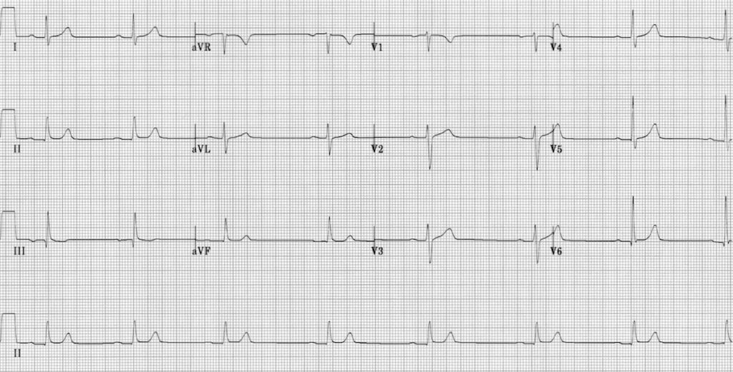

https://litfl.com/wp-content/uploads/2018/08/ECG-Sinus-bradycardia-1st-degree-AV-block.jpg
ECG #2
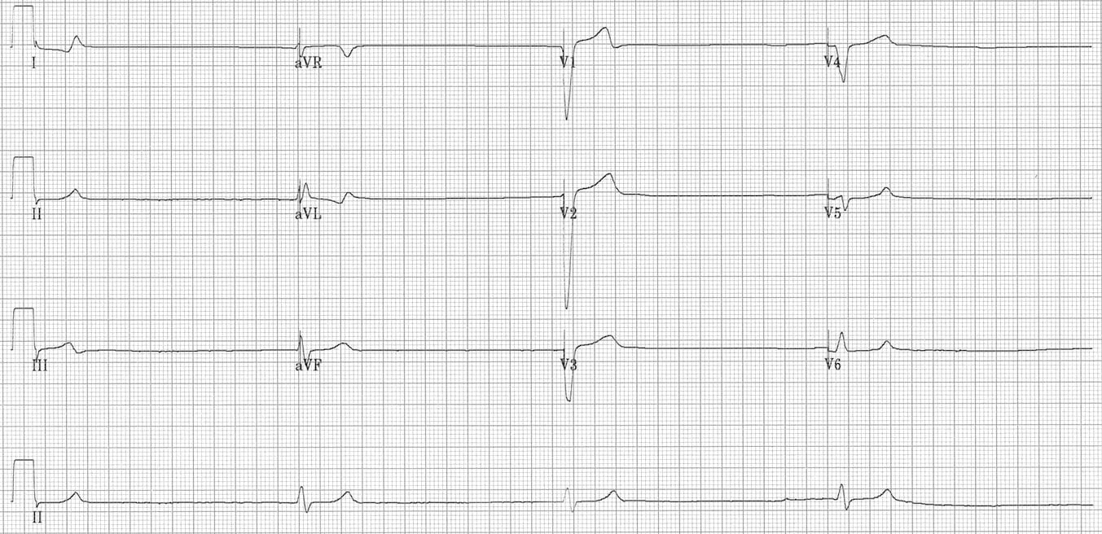

https://litfl.com/wp-content/uploads/2018/08/sinus-arrest-ventricular-escape-rhythm-2.jpg

Appendix C: Facilitator Cheat Sheet & Debriefing Tips

Include key errors to watch for and common challenges with the case. List issues expected to be part of the debriefing discussion. Supplemental information regarding any relevant pathophysiology, guidelines, or management information that may be reviewed during debriefing should be provided for facilitators to have as a reference.

Debriefing as a group, without video.

Sample questions for debriefing:

CRM
- How do you prioritize interventions with a patient that is predicted to become critically unwell?
- How can you use the team to effectively communicate with resources (e.g. poison control/ICU) while managing an unstable patient?

Medical Expert
- What are the common effects of beta blocker toxicity?
- Hypotension, bradycardia, AV block, cardiovascular collapse

- Does it differ with propranolol, acebutolol, and sotalol?
- Propranolol and Acebutolol cause Na channel blockade QRS widening NaHCO₃ boluses
- Sotalol causes K+ blockade Long QT Monitor for Torsades MgSO₄

- What electrolyte changes can you anticipate in a beta blocker overdose?
- Hypokalemia / Hypoglycemia. After starting high dose insulin and dextrose, repeat K+ and Glucose q30 minutes. Hyperglycemia may occur transiently.

- What decontamination strategies could be considered in this patient?
- Activated charcoal: Traditionally 1-2 hours from time of ingestion, though most experts advocate for extending the window to 4-6 hours. Administration can be discussed with poison control on a case-by-case basis.
- Gastric lavage: Can be considered as the patient has presented within one hour of presentation. Although rarely recommended, for potentially lethal ingestions, presenting within one-hour, gastric lavage can (and should) be considered. Requires airway protection, thus prophylactic intubation.
- Whole bowel irrigation: NOT currently indicated. May be considered with ingestion of sustained release preparations.

References

1. https://www.bcemergencynetwork.ca/clinical_resource/beta-blockers-overdose/
2. https://www.uptodate.com/contents/beta-blocker-poisoning#H27
3. https://emergencymedicinecases.com/low-slow-poisoning/

